
working

Safety and Health Representatives are important because it makes sense for employers and employees to talk to each other about safety at work. The experience and knowledge of employees can make a significant contribution to identifying and controlling hazards and risks, and developing preventative measures to address health and safety issues that arise at the workplace.

A Safety and Health Representative is the key to communication by making it easier to exchange ideas and concerns about safety between employers and employees. Safety and health representatives raise and discuss safety issues and concerns with employers and/or managers so they can work together and arrive at solutions to make the workplace safe.

On completion of this course, you should be able to: -

- Apply knowledge of legislation in the role of a Safety and Health Representative;
- Identify and locate information from a variety of sources;
- Identify and evaluate hazards in the workplace and recommend control methods;
- Conduct an effective inspection of their workplace;
- Conduct an effective investigation into workplace illness/injuries and accidents;
- Communicate on Safety and Health matters and represent employees;
- Describe the functions, make up and roles of Safety and Health Committee;
- Resolve conflict and issue Provisional Improvement Notices (PINs)
when appropriate.

Course date: Monday 29 August - Friday 2 September, 2016 (5 day course)
Course duration: 8.30am - 4.30pm
Training provider: Industrial Foundation for Accident Prevention (IFAP)

Course venue: Industrial Foundation for Accident Prevention (IFAP), 128 Farrington Rd, NORTH LAKE
Cost includes: A light lunch, morning and afternoon teas.
You must advise, prior to course date, if you have any special dietary requirements.

*Prices subject to change. ^Construction Training Fund (CTF) subsidy available for eligible course participants.
The course component only is GST free. The course includes meal and refreshments at $25 per day, plus GST.

*Prices subject to change. ^Construction Training Fund (CTF) subsidy available for eligible course participants.
This course is GST FREE

The Construction Training Fund provides funding support for training of eligible workers in the construction industry.
We acknowledge the support of the Construction Training Fund in reducing costs of training for eligible workers.
 | Course Fee | Total
MBA Member eligible for CTF subsidy | $1201.50 - $838.25^ | $ 363.25*
Non-member eligible for CTF subsidy | $1335.00 - $838.25^ | $ 496.75*
MBA Member | $1201.50 | $1201.50*
Non-member | $1335.00 | $1335.00*

If you require further assistance please call Master Builders on 9441 8000 or email training@mbawa.com
Upon successful completion of this course you will be issued with a Certificate of Attendance.

 | 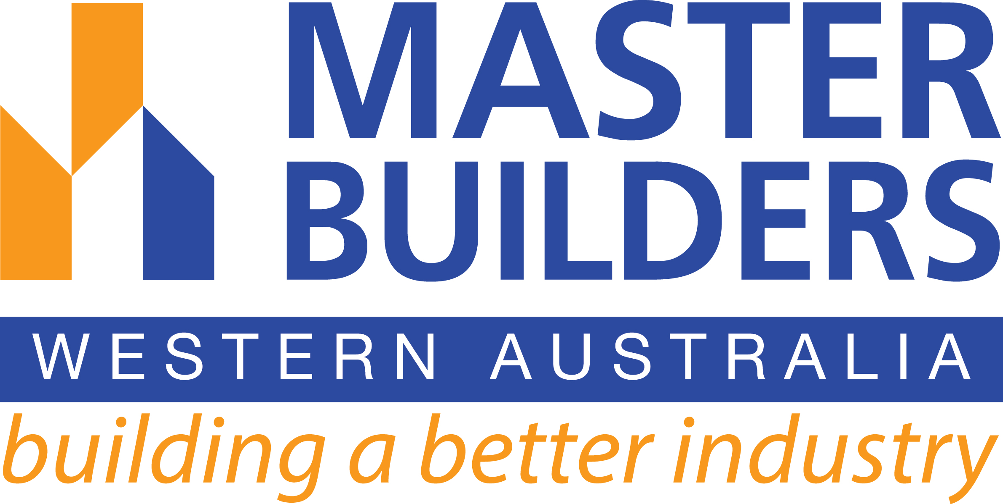 | 
SAFETY & HEALTH REPRESENTIVE
8.30am – 4.30pm (5 day course)

Please Note: This course is subsidised by the Construction Training Fund (CTF) for eligible participants.
Master Builders requires participants details to be provided as indicated below, otherwise the full fee may apply.
Course date: Monday 29 August - Friday 2 September, 2016 (5 day course)

PARTICIPANT DETAILS
Surname: |  |  |  | First Name:
Date of birth: |  |  |  |  |  |  |  | Gender: (please circle) Male / Female
Email: |  |  |  | Mobile:
Home address:
Suburb: |  |  |  |  |  |  |  |  |  | Postcode:
Job/Trade title:
Job description (brief detail):
Is English your first language?: (please circle) Yes / No |  |  |  | If NO, what language do you speak?
EMPLOYER/COMPANY DETAILS:
Master Builders member name:
Employer/Company name: |  |  |  |  |  |  |  | Builders Reg.number:
Address:
Suburb: |  |  |  |  |  |  |  |  |  | Postcode:
Contact Name: |  |  |  |  |  |  | Email:
Phone: |  | Fax: |  |  |  |  |  | Mobile:
Please tick the industry sector in which you work |  |  |  |  |  | Commercial □ Housing □ Engineering □

PAYMENT DETAILS
Payment must be received prior to the course date to secure your place & receive your confirmation
EMAIL: training@mbawa.com FAX: 9476 9881
POST: Master Builders Association, P.O. Box 167, West Perth WA 6981
Course Costs | Master Builder member | Non-member
Eligible for CTF subsidy | $ 363.25 per person | $ 496.75 per person
Not eligible for CTF subsidy | $1201.50 per person | $1335.00 per person

Please note that course costs are subject to change. The course component is GST free.
The course includes meal and refreshments at $25 per day, plus GST.

Method of Payment | Cash □ Cheque □ Credit Card □ EFT □ |  |  |  |  |  |  |  | Amount: $
Credit Card Details: (please tick) |  |  | Bankcard □ MasterCard □ Visa □
Card number: _ _ _ _ / _ _ _ _ / _ _ _ _ / _ _ _ _ |  |  |  |  |  |  |  |  | Expiry Date: _ _ / _ _
Cardholders Name: |  |  |  |  | Signature:

Cancellation Notice | A refund will not be provided for no shows on the day of the course or cancellations less than 5 working days  prior to the course date. You may, however, substitute another person up to 48 hours prior to the course.

If you require further assistance please call Master Builders on 9441 8000 or email training@mbawa.com

To view our Terms & Conditions please visit www.mbawa.com

